**PYTHON PROJECT**



**WRITE A PYTHON PROGRAM FOR CREATING OWN REPORT CARD DISPLAY UR GRADE AND DISPLAY (SUBJECT TOPPER)………**

NAME :- NITIN NAMDEV PAWAR

DIVISION :- C

ROLL NO :- 6384

CLASS :- SYBSCIT



**MAHATMA EDUCATION SOCIETY’’S**

**PILLAI’S COLLEGE OF ARTS,**

**COMMERECE & SCIENCE**

(AUTONOMOUS INSTITUTION AFFILATED TO THE UNIVERSITY OF MUMBAI)

DR K.M. VASUDEVAN PILLAI CAMPUS, SECTOR 16, NEW PANVEL 410206.

(NAAC ACCREDITED ‘A’ GRADE)

CERTIFICATE

THIS IS TO CERTIFY THAT MS/MR NITIN NAMDEV PAWAR

ROLL NO 6384 , DIV C ,

CLASS SYBSCIT HAS WORKED AND DULY COMPLETED HER/HIS PROJECT WORK FOR THE BACHELOR IN SCIENCE

(INFORMATION TECHNOLOGY) UNDER THE FACULTY OF SCIENCE IN THE

SUBJECT ’OF PYTHON AND PROJECT ENTITLED

**WRITE A PYTHON PROGRAM FOR CREATING OWN REPORT CARD DISPLAY UR GRADE AND DISPLAY (SUBJECT TOPPER)………**

I FURTHER CERTIFY THAT THE ENTIRE WORK HAS BEEN DONE BY THE

LEARNER AND SUCCESSFULLY COMPLETED HIS PROJECT WORK FOR

SEMESTER-III YEAR 2020-2021.

**ASST. PROF. SANJANA BHANGALE**

* **INTRODUCTION TO PROJECT :-**

**Every school needs to generate a Report Card, be it annually or term wise. This project i.e. " WRITE A PYTHON PROGRAM FOR CREATING OWN REPORT CARD DISPLAY UR GRADE AND DISPLAY (SUBJECT TOPPER)………**

**" aims at reducing the manpower and wastage of paper due to the same.This program has 6 parts, New Data Entry, stored marks, Display mark sheet,Display Grade , Display top 3 subject topper students of a class, Display students eligible for scholar badge.**

* **The first part "New data entry", updates the database with a new entry. This part can be useful if a new student joins the school.**
* **Second part " stored marks", updates the existing entry with a new data of marks.**
* **Third, "Display mark sheet " displays the mark sheet in tabular format.**
* **Fourth, "Display grade sheet " displays the grade sheet in tabular format.**
* **Fifth module Display top 3 subject topper students of a class,**
* **Last but not the least part, displays the students of a class eligible for Next year(above 35% in each subject then eligible).**
* **Some points I use in this project:**

**1)Loops:**

**a)For loop**

**b)If elif else**

**2)Method:**

**a)Append**

**3) function:**

**a) Max**

**code:**

**##WRITE A PYTHON PROGRAM FOR CREATING OWN REPORT CARD DISPLAY UR GRADE AND DISPLAY (SUBJECT TOPPER)………**

**print(" " ," 🙏 Welcome to 🙏 "," ")**

**print("***********************************************************************")**

**print(" ","!.....","Mahatma Education Society's"," .....! ")**

**print(" ","🌻🌻🌻🌻 Pillai Institute of Information Technology 🌻🌻🌻")**

**print("***********************************************************************")**

**print(" ","ENTER CLASS STUDENT DETAILS"," ")**

**n = int(input("PLEASE ENTER THE TOTAL NO.OF STUDENTS:"))**

**all_students = []**

**sub1=[]**

**sub2=[]**

**sub3=[]**

**name=[]**

**for i in range(0, n):**

**stud_name = input('ENTER THE NAME OF STUDENT: ')**

**print (stud_name)**

**name.append(stud_name)**

**stud_rollno = input('ENTER THE ROLL NO. OF STUDENT: ')**

**print (stud_rollno)**

**mark1 = int(input('ENTER THE MARKS OF SUBJECT1 OUT OF 100: '))**

**print (mark1)**

**sub1.append(mark1)**

**mark2 = int(input('ENTER THE MARKS OF SUBJECT2 OUT OF 100:: '))**

**print (mark2)**

**sub2.append(mark2)**

**mark3 = int(input('ENTER THE MARKS OF SUBJECT3 OUT OF 100: '))**

**print (mark3)**

**sub3.append(mark3)**

**total = (mark1+mark2+mark3)**

**avg = total / 3**

**print( "AVERAGE OF YOUR MARKS :", avg)**

**print("***************************************************************************")**

**if(avg>=90):**

**print("Grade: A+")**

**print("CONGRATS YOUR PROMOTED TO NEXT CLASS")**

**elif(avg>=80):**

**print("Grade: A")**

**print("CONGRATS YOUR PROMOTED TO NEXT CLASS")**

**elif(avg>=70):**

**print("Grade: B+")**

**print("CONGRATS YOUR PROMOTED TO NEXT CLASS")**

**elif(avg>=60):**

**print("Grade: B")**

**print("CONGRATS YOUR PROMOTED TO NEXT CLASS")**

**elif(avg>=50):**

**print("Grade: C+")**

**print("CONGRATS YOUR PROMOTED TO NEXT CLASS")**

**elif(avg>=40):**

**print("Grade: C")**

**print("CONGRATS YOUR PROMOTED TO NEXT CLASS")**

**elif(avg>=35):**

**print("YOU ARE GRACED PASS")**

**print("Grade: D")**

**else:**

**print("YOU ARE FAILED,TRY HARDER NEXT TIME")**

**print("Grade: F")**

**print("THANK YOU")**

**print("***************************************************************************")**

**all_students.append({**

**'NAME:-': stud_name,**

**'ROLL NO:-': stud_rollno,**

**'SUBJECT1:-': mark1,**

**'SUBJECT2:-': mark2,**

**'SUBJECT3:-': mark3,**

**'TOTAL MARKS OBTAINED OUT OF 300': total,**

**'AVERAGE OF YOUR MARKS': avg**

**})**

**print("***************************************************************************")**

**print('')**

**print('RESULTS')**

**print("---------")**

**for student in all_students:**

**print( '\n')**

**print("***************************************************************************")**

**for key, value in student.items():**

**print ('{0}: {1}'.format(key, value))**

**print('')**

**print("***************************************************************************")**

**print('SUBJECTWISE TOPPERS 2019-20 OF OUR CLASS:- ')**

**print("***************************************************************************")**

**print('')**

**print('CONRATULATIONS....')**

**print("***************************************************************************")**

**print("***************************************************************************")**

**print('')**

**print('Highest marks in SUBJECT1:-',max(sub1))**

**print('SCORED BY:-',name[sub1.index(max(sub1))])**

**print('')**

**print("***************************************************************************")**

**print('Highest marks in SUBJECT2:-',max(sub2))**

**print('SCORED BY:-',name[sub2.index(max(sub2))])**

**print('')**

**print("***************************************************************************")**

**print('Highest marks in SUBJECT3:-',max(sub3))**

**print('SCORED BY:-',name[sub3.index(max(sub3))])**

**print(" "," 🙏 THANK YOU 🙏")**

**print("***********************************************************************")**

**Output:**

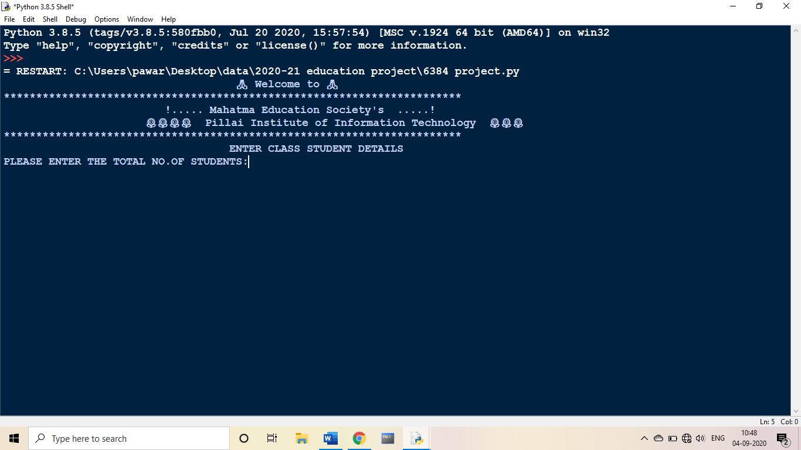

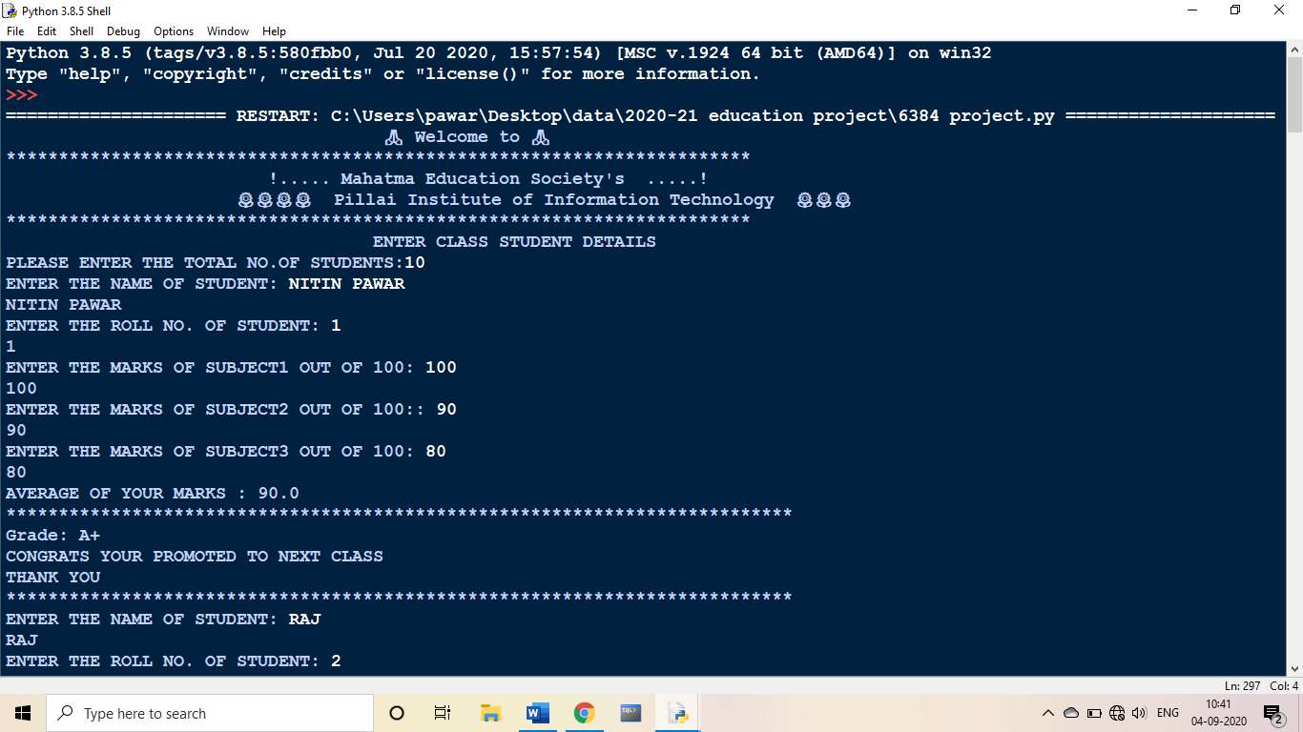 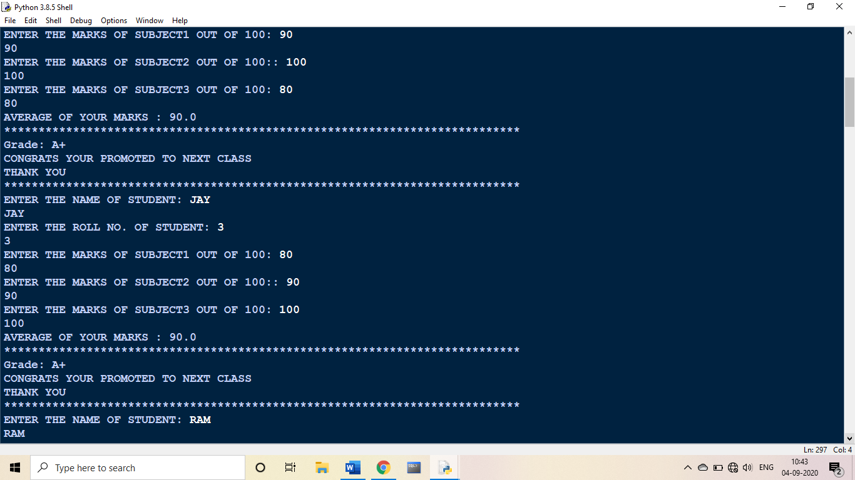 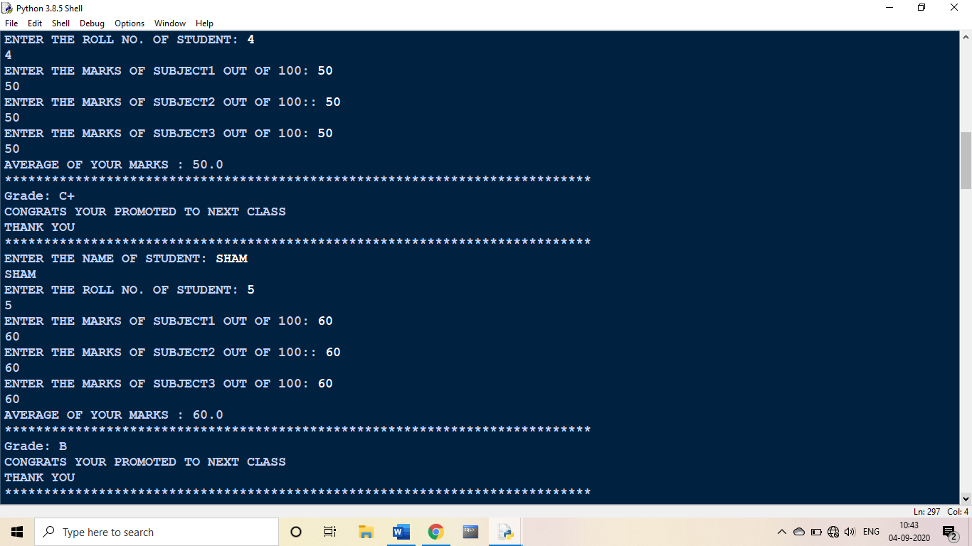 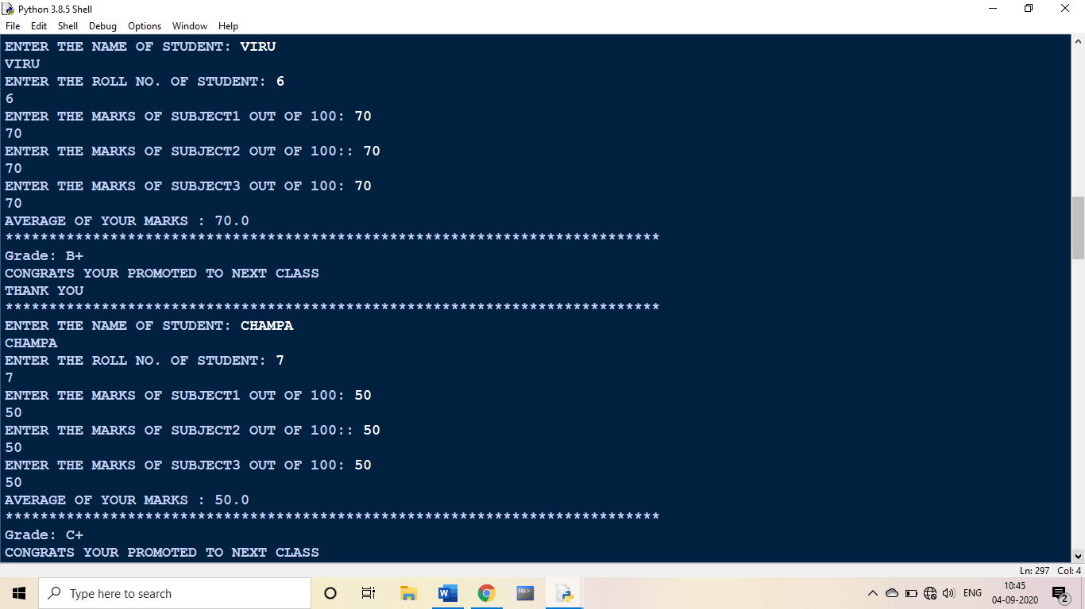 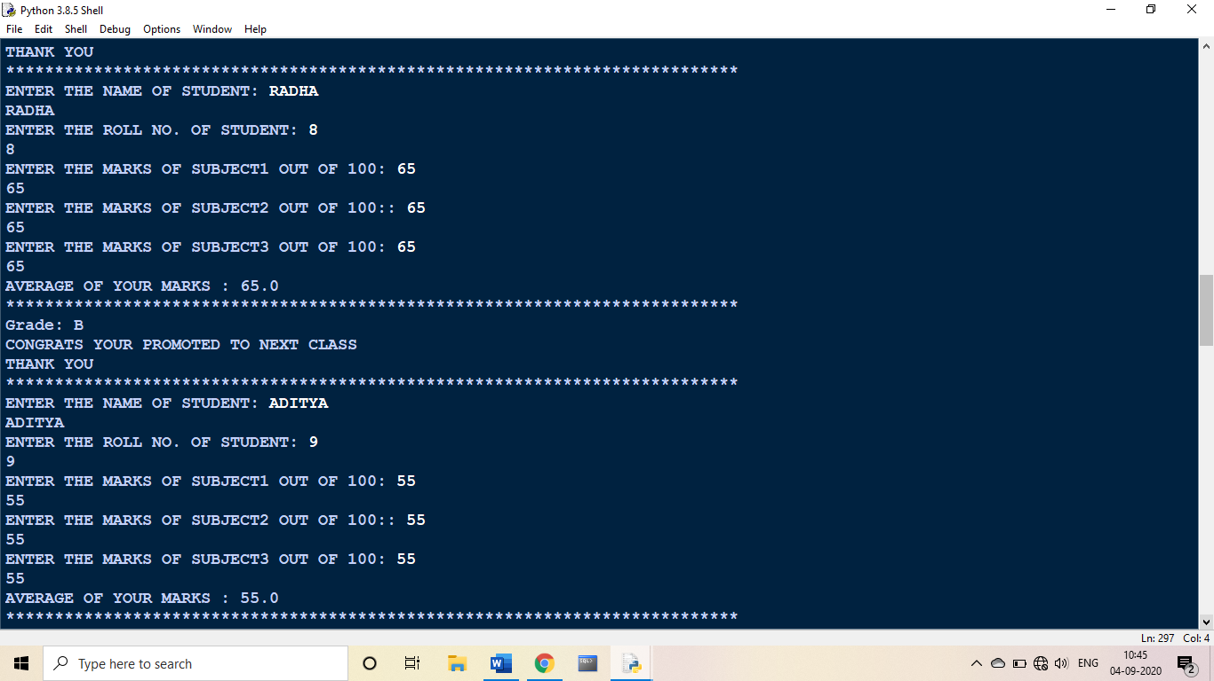 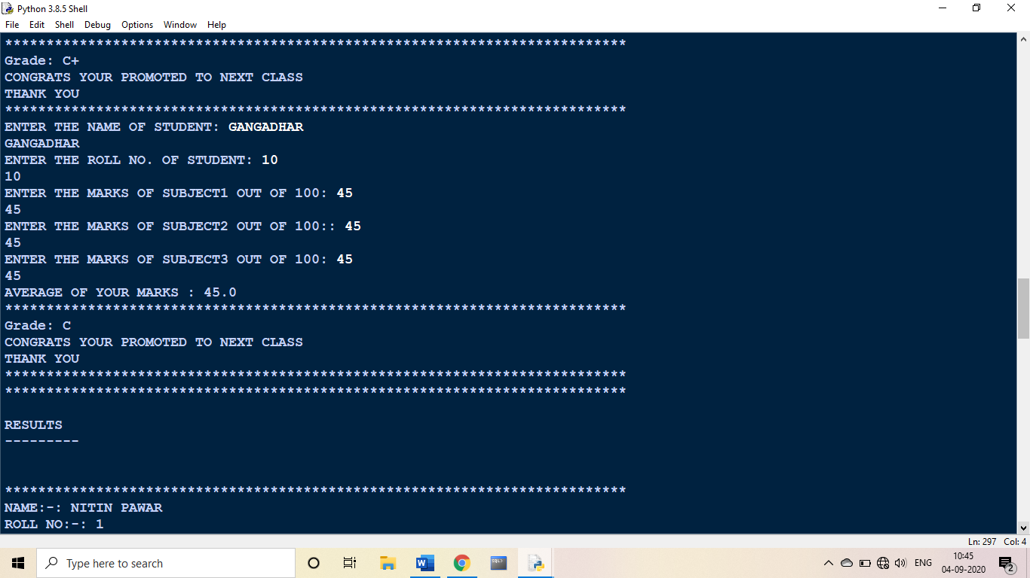 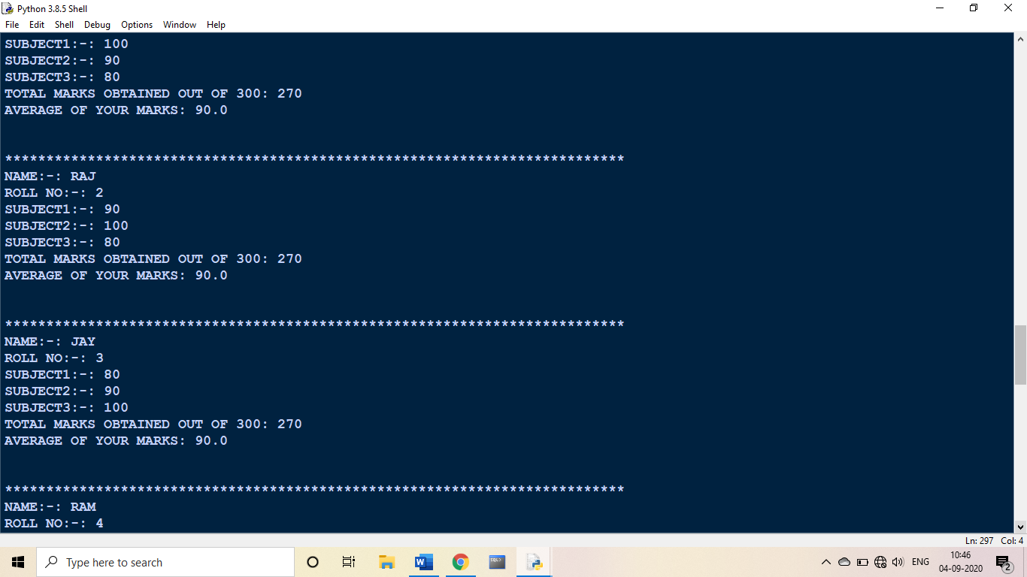 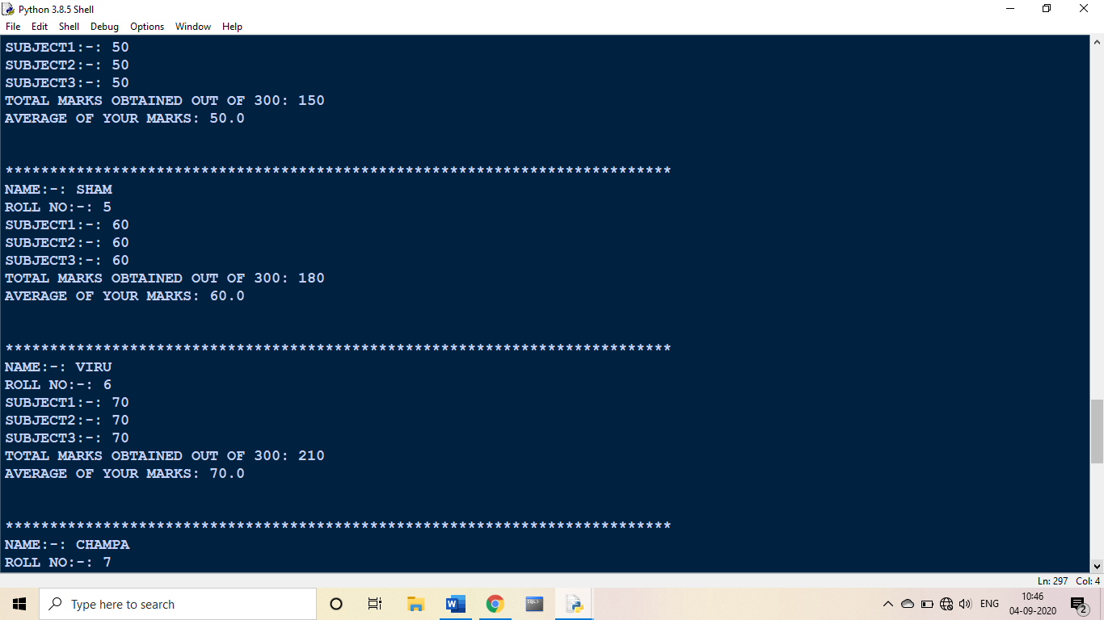 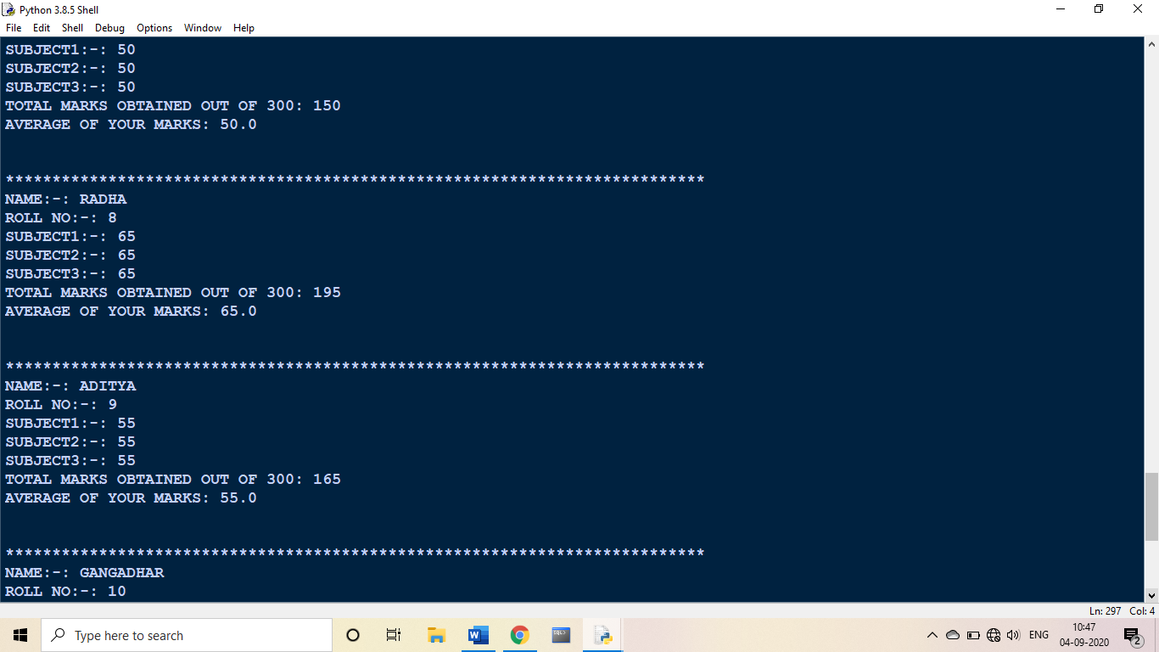 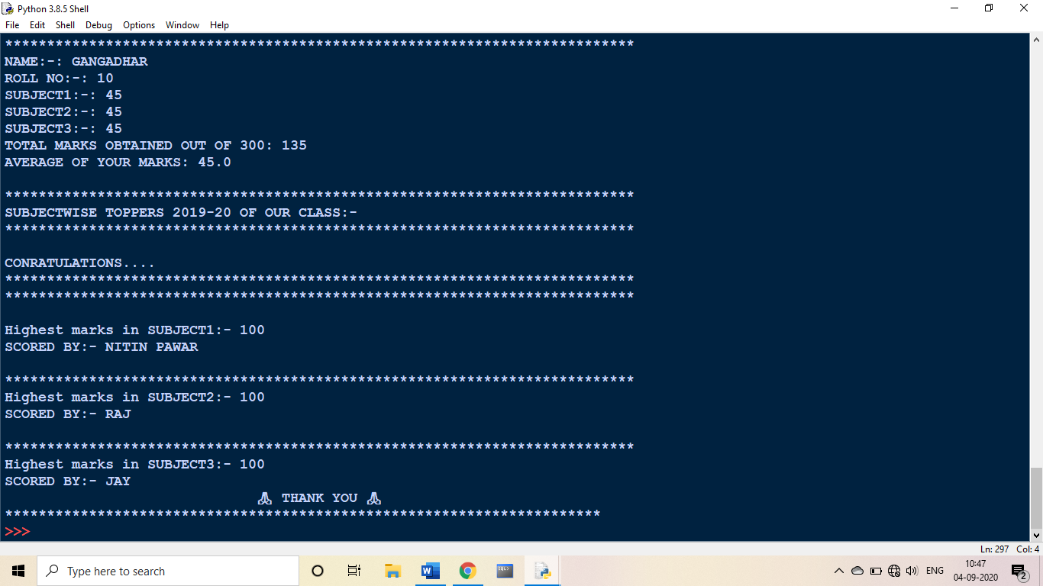

**Thank you**